Subject: Discrete Mathematics
EXERCISES - CHAPTER 2: Basic Structures: Sets, Function, Sequences, and Sums

Book: Discrete Mathematics and Its Applications, 6th Edition
Author: Kenneth H. Rosen
Publisher: McGraw-Hill International Edition
Total: 21 exercises

120 | 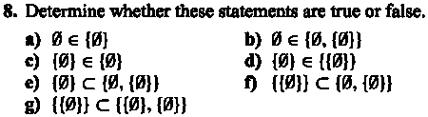  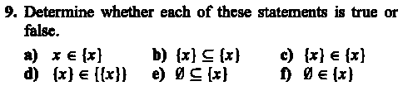  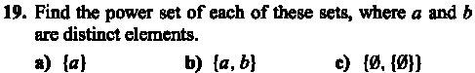  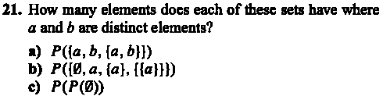
130 | 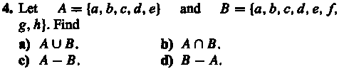  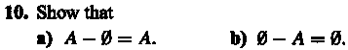
131 | 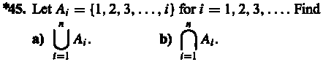  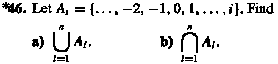  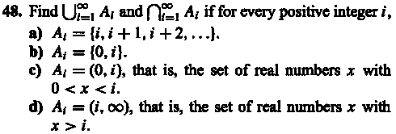
146 | 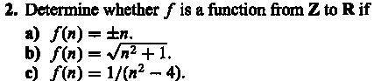  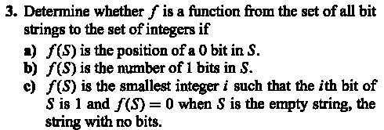
147 | 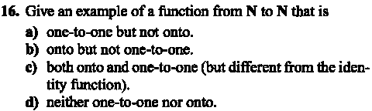  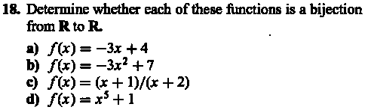  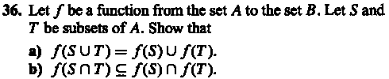
160 | 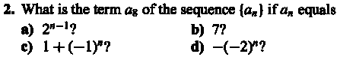
161 | 